An opportunity to use AI to create annual payment schedules

**Summary**

We are seeking to use AI to identify patterns from the existing payment schedules for the past 25 years and then generate payment schedules for each upcoming year.

We are also seeking AI to define business rules for the creation of future payment schedules.

**Background**

Currently, there are 4 tables in legacy system that determine when the payments are issued by taking into account claim cycle date, weekends and holidays (tables 107 (weekend/holiday dates), 108 (WBS Review Notices Dates), 109 (Weekend/Holiday Table in Arrears) and 122 (Monthly Business/Weekend/Holiday Date)).

Every year, entries for each month are created by an individual by applying certain rules but also some not well-defined exceptions.

Example of Jan 202 entry for table 107:

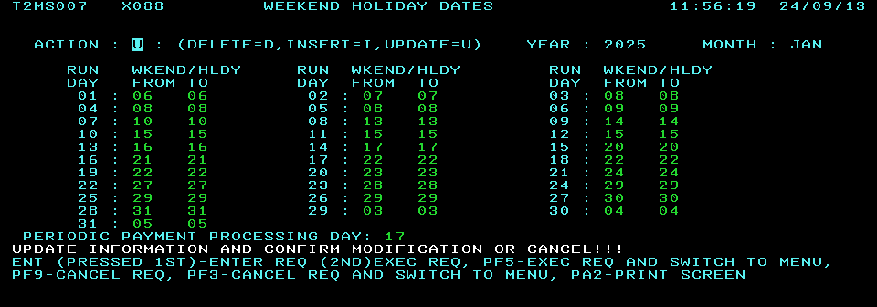

**Example of some business rules and ambiguities:**

Business Rules

1. To determine what the system will process to, look at the run date (i.e. the calendar date) & add 3 working days. (The 3 days do not include the run date.)

¨ Ensure that the Board is open for all 3 working days. For example, on Wednesday April 19, 2000 we paid to Wednesday April 26 (instead of to Monday April 24) because the Board’s offices were closed for Good Friday & Easter Monday.)

¨ For Saturday & Sunday run dates, enter the same date that was chosen for the Friday.

¨ The date entered for a holiday (on a regular working day, i.e. not Saturday/Sunday) is the same as the previous working day. For example, on a holiday Monday, the weekend/holiday date is the same as it is for the previous Friday.

¨ For the accelerated payment schedule at Christmas, check previous schedules for guidance. (Current schedule illustrates that the accelerated schedule starts mid-month on the Thursday.)

2. Generally, the schedule for issuing payments is as follows:

Run Date Issues for (non-inclusive)

Monday Thursday

Tuesday * Friday

Wednesday Saturday, Sunday & Monday **

Thursday Tuesday

Friday Wednesday

* Normally, Tuesday night runs will pay to Friday. However, if the Monday is a holiday, the input should be made to pay to Monday. This will ensure that the worker receives their cheque in time.

** The date of the Monday (in normal processing weeks) will be entered.

**Business problem:**

The manual process of creation of payment schedule occurs every year. Since it is manual, it is prone to errors and time consuming (both creation and validation).

We are looking for the ways to automate it.

**Solutions:**

1. Immediate solution MF team is looking to create:
   1. Extract table values for exact prior year (<https://www.timeanddate.com/calendar/repeating.html>) and use them to create a record for the upcoming year
   2. Have a validation done and manually update of the months with new holidays (Family, Reconciliation day) and December.
   3. Once validation complete by all stakeholders, promote to production and copy to lower environments.

**Benefit**: it is an interim step to gain immediate benefit and semi-automation, saves time, less prone to error

1. AI enabled solution:
   1. Provide AI with the input of 25 years of existing payments schedule tables + calendars + WSIB observed holiday dates for each year
   2. Expected output: completely defined business rules & ability to generate payment schedule values for the upcoming years in the format that can be uploaded to mainframe tables.

**Benefit**: saves time of creation and multiple validations of the values, cuts down the risk of error, generated business rules can be utilized for the build of the new Payment Distribution System.